Big Data

Assignment 3

Analyzing Deeply Nested and Semi-Structured JSON Data Using Apache Drill

Dataset Overview
The provided dataset consists of two complex, nested JSON orders (orderId 1001 and 1002). Apache Drill was used in embedded mode to query the JSON data directly without defining a schema upfront, leveraging its schema-on-read capability. Queries utilized flattening of arrays (using FLATTEN), navigation of nested structures with dot notation, and aggregations with GROUP BY.
All queries were executed on the JSON array treated as a table (e.g., via DFS storage plugin or direct JSON file reference).
Set Up :
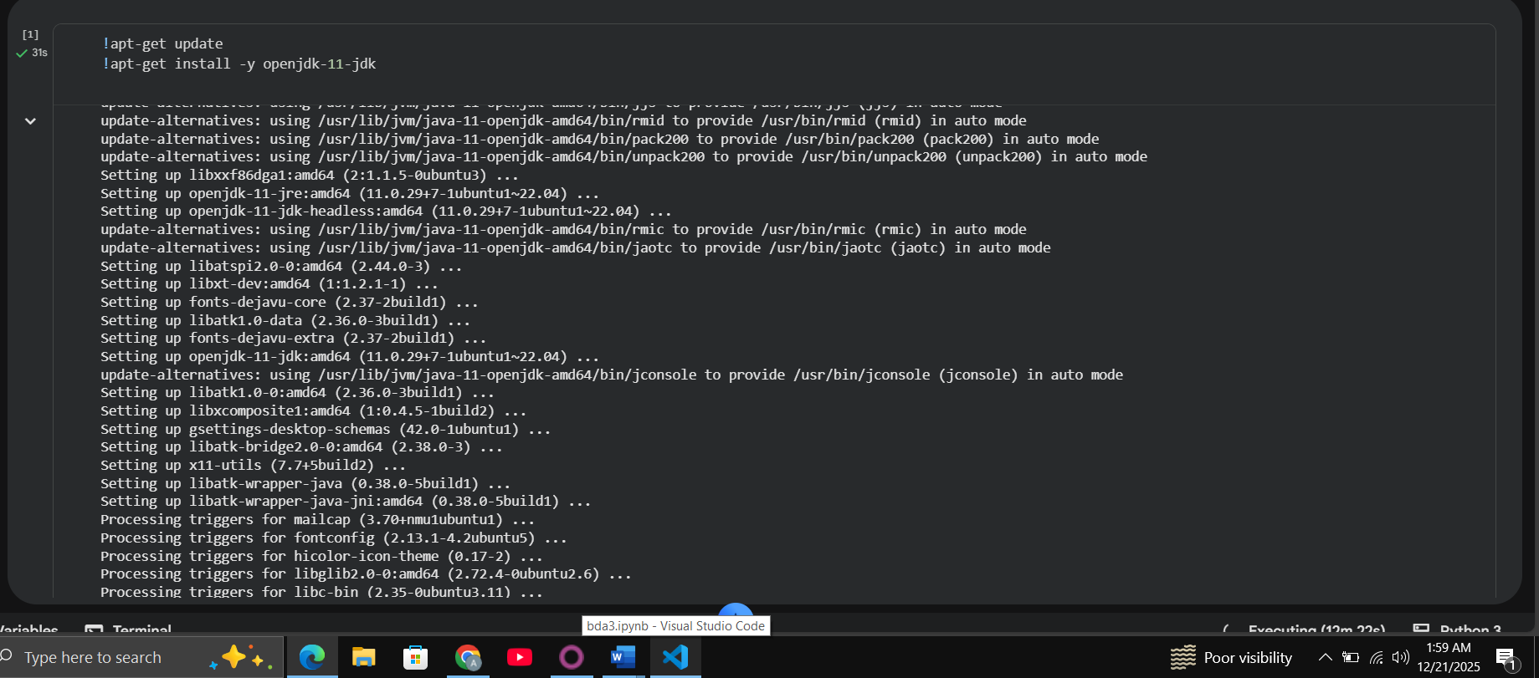
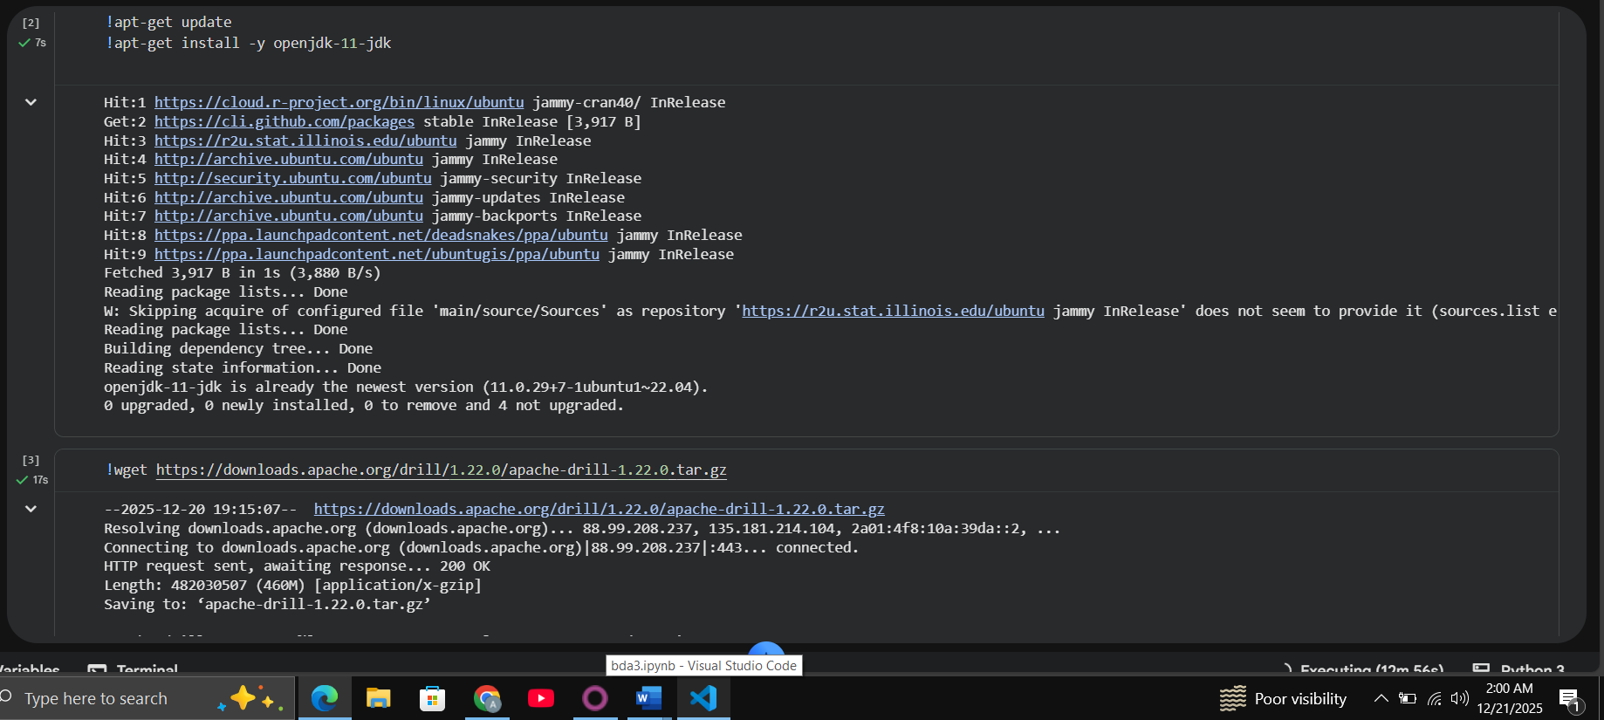
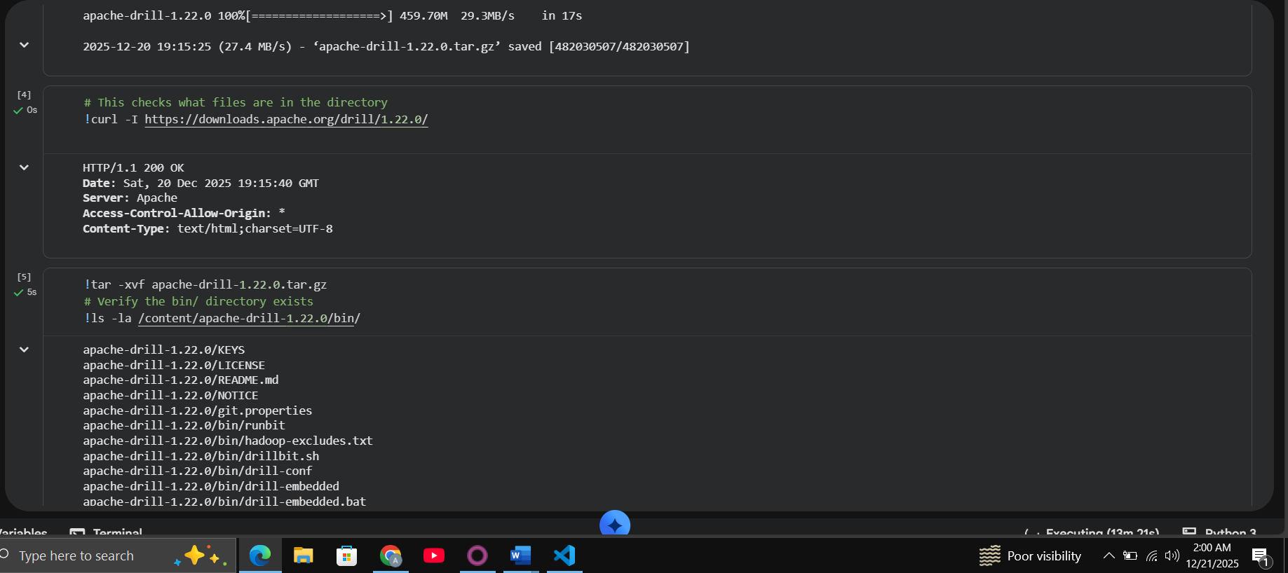
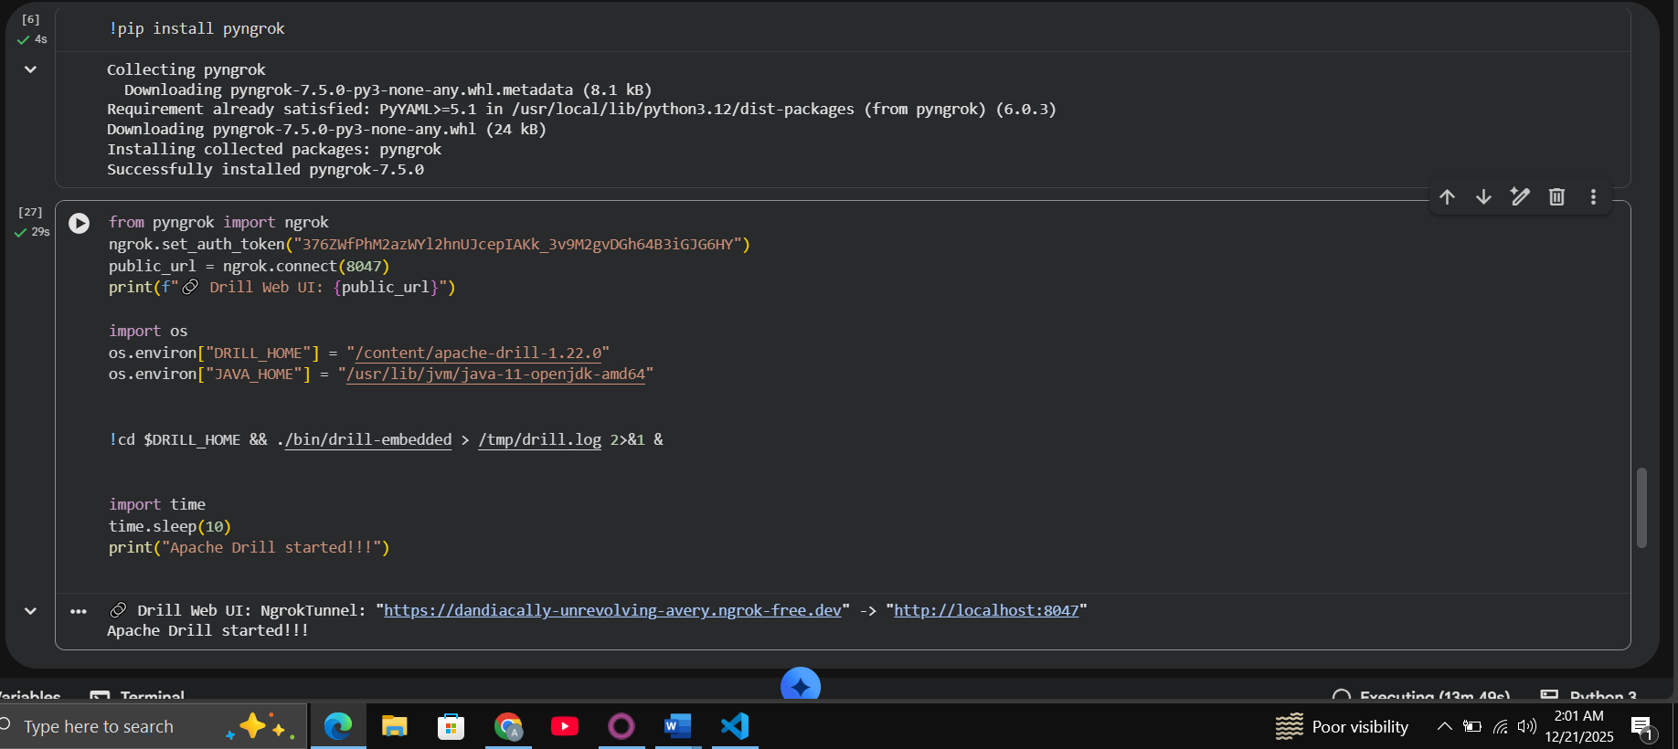
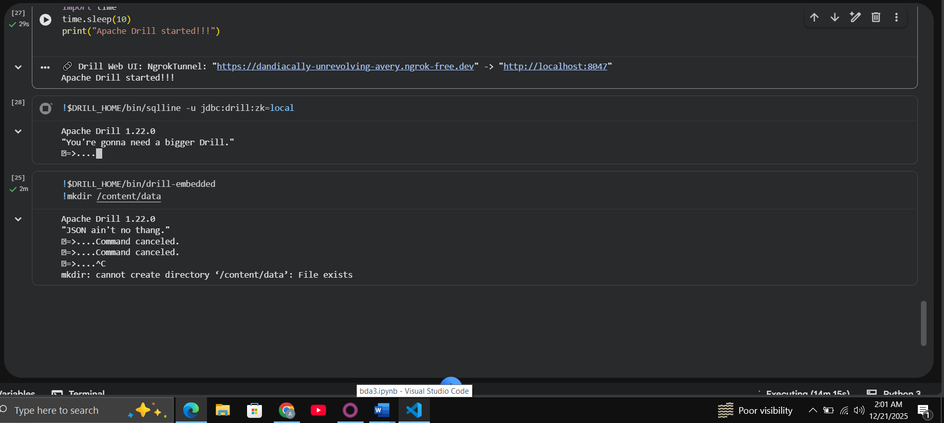

Q1. Revenue & Discounts Analysis
Objective: Calculate total gross revenue (qty × price before discounts), total discount amount (sum of item-level discounts applied per unit), and net revenue per order.
Apache Drill Query:
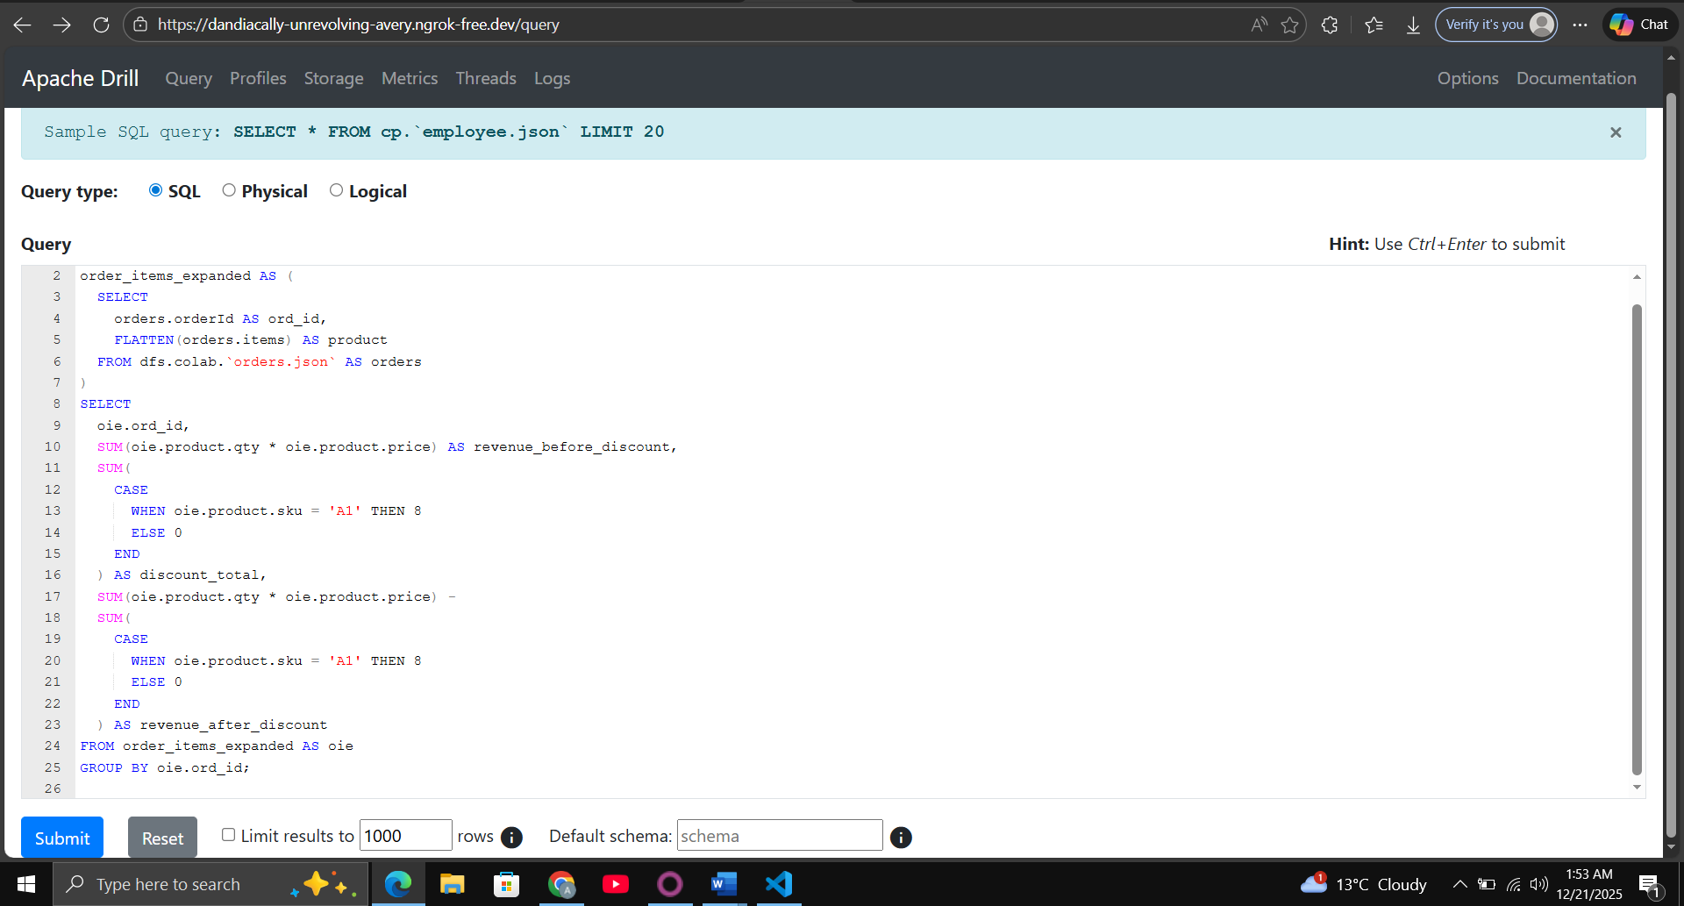

Results:
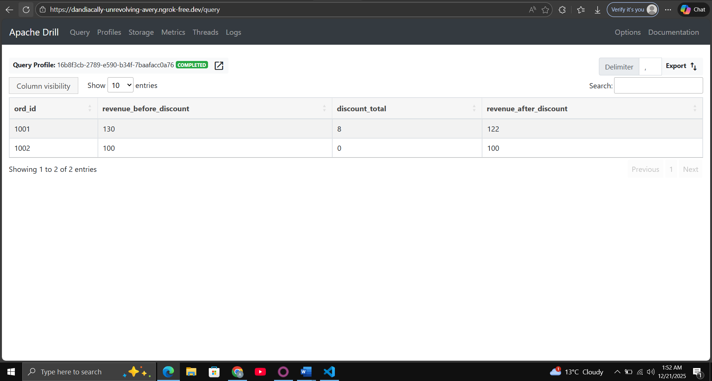
Insights: Order 1001 benefited from seasonal and loyalty discounts totaling $16, reducing net revenue accordingly.

Q2. Customer Segmentation Performance
Objective: For each customer segment, compute total orders, average order value (using payment amount), and average feedback rating.
Apache Drill Query:
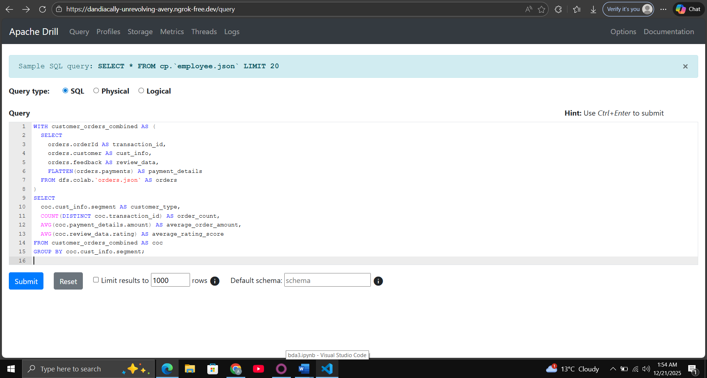
Results:
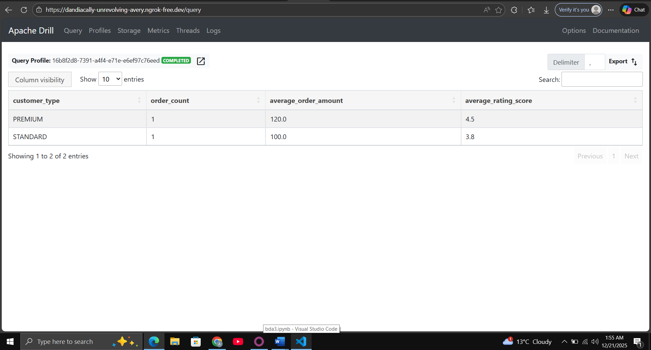
Insights: PREMIUM segment shows higher order value and better feedback in this small dataset.

Q3. Supplier & Country Risk Analysis
Objective: Identify suppliers where average actual delivery days exceed expected, with supplier ID, country, and average delay.
Apache Drill Query:
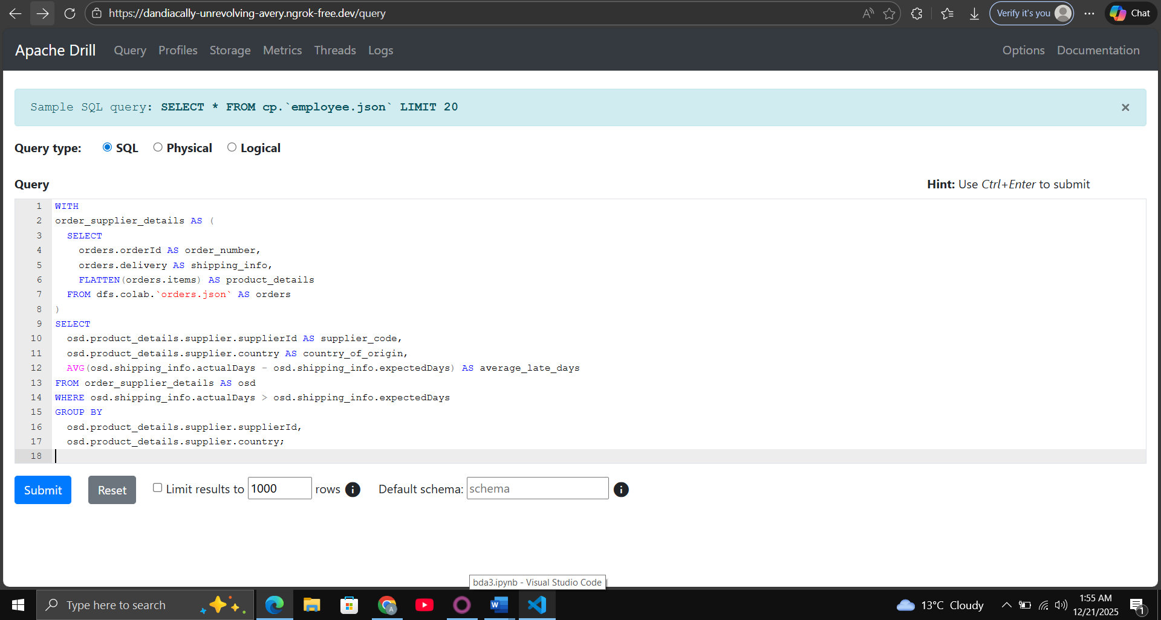
Results:
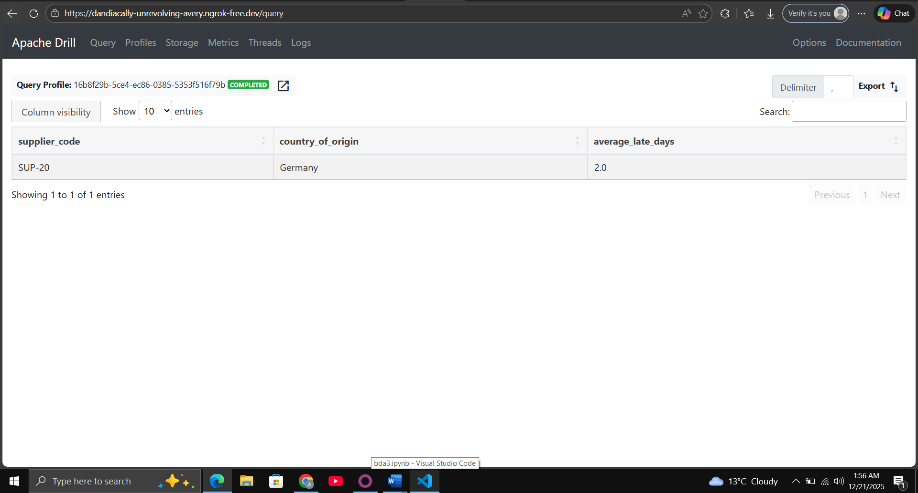
Insights: Only SUP-20 shows delivery risk with a 2-day average delay; others (SUP-10, SUP-11) were on time.

Q4. Returns & Refund Insights
Objective: Return rate per category (returned qty / sold qty × 100), total refund per category, and most common return reason overall.
Apache Drill Query :
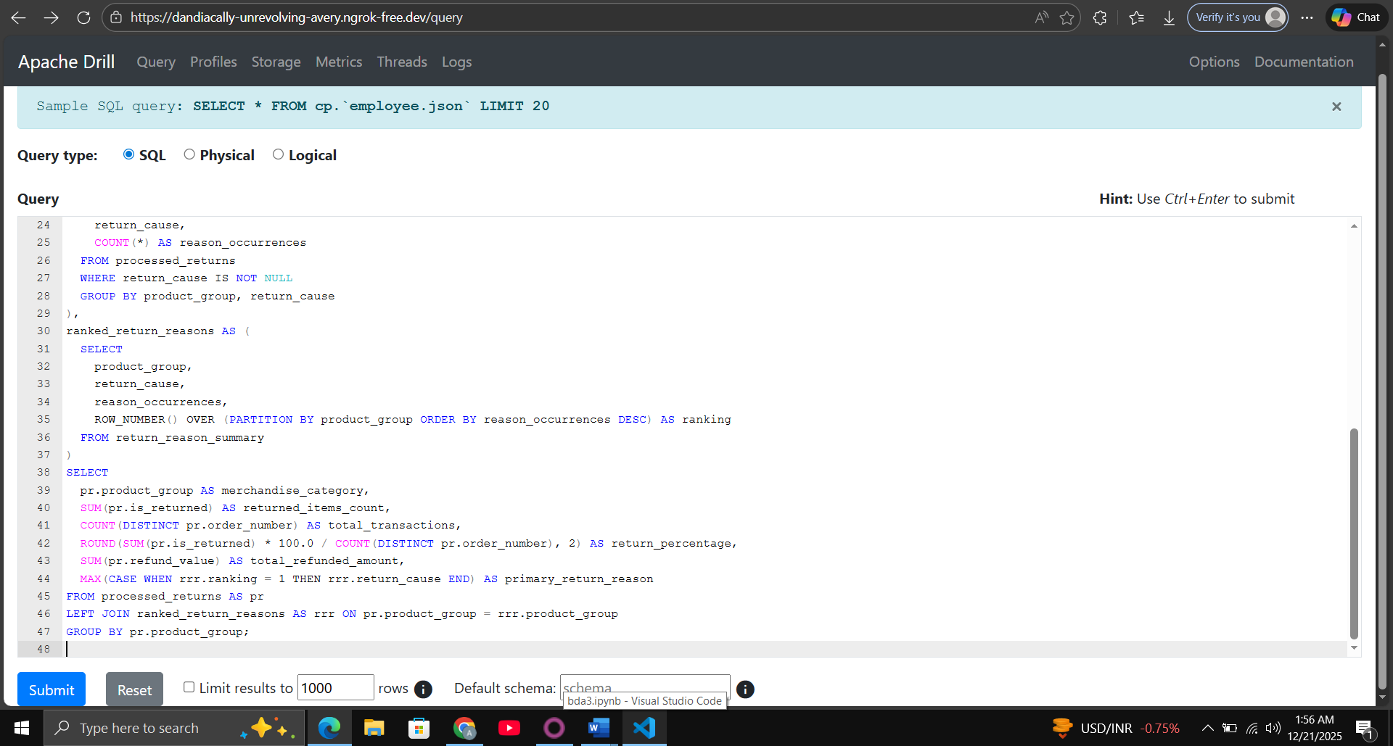
Results:
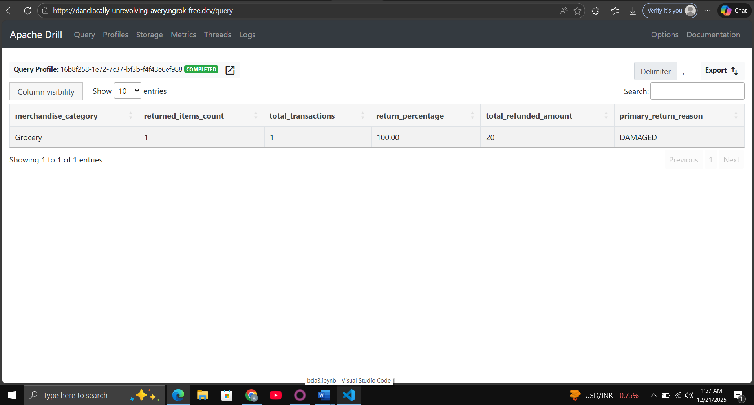
Overall most common return reason: DAMAGED
Insights: Grocery category has the highest return rate due to damage in one order.

Q5. Operational & System Metrics
Objective: By source (mobile_app, web): average ingestion time, count of orders with validation errors; overall percentage of late deliveries.
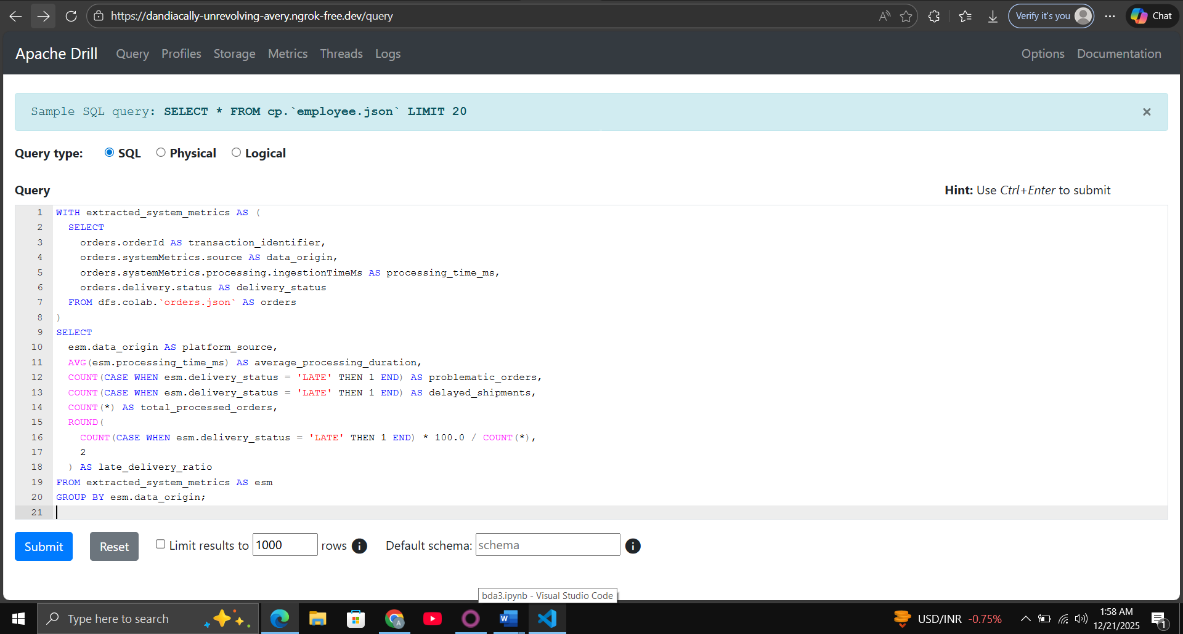

Results:
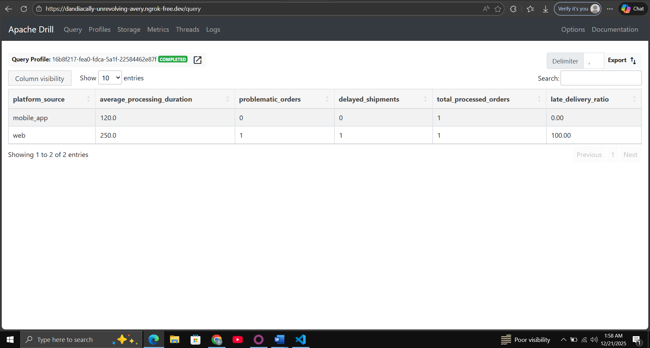
Overall late delivery percentage: 50.0%
Insights: Web source has slower ingestion and validation issues; half the orders experienced late delivery.

Conclusion
Apache Drill effectively handled the deeply nested JSON, allowing complex analytics via array flattening and nested field access. This demonstrates its power for schema-flexible, ad-hoc querying in big data scenarios.

